Sermon Preview: Mission Mysteries: (1) Why Plan B (or C, or D) Lord?
Sunday: October 6, 2013

Text: 2 Corinthians 11:21b-33, 2 Corinthians 12:6-10

The purpose of the Sermon preview is to enable you to wrestle with the passage before Sunday. This can enable you hear and apply God’s Word better because you have some prior knowledge of both the passage and message before you arrive on Sunday.

Paul Spoofs the Boasters

Read 2 Corinthians 11:21b-33. Notice how Paul spoofs the boasting culture. In his book, Paul For Everyone: 2 Corinthians (pages 124-129), Tom Wright points out that “Paul boasts in all the wrong things.” Imagine a basketball player rapping in the following way:

Just got beeped for crossing the free throw line
Already got blocked 2, 3, no, 6 times!
I turnover more than a pastry at the bakery
So green a seven year old can fake me.

A basketball player who boasts like that either doesn’t
understand the game or he is teasing the fanatics who
idolize the game.

Paul’s best spoofing comes in verse 32-33:

In Damascus the governor under King Aretas had the city of the Damascenes guarded in order to arrest me.
But I was lowered in a basked from a window in the wall and slipped through his hands.

In Roman warrior culture, the most coveted prize was the corona muralis. This prize
went to the soldier who was the first one over a city wall in battle. Such a soldier was the most exposed and vulnerable to arrows or hot wax falling down on him. If he did climb the ladder and reach the top of the wall then he had to engage in hand to hand fighting with waiting soldiers at the top. Somehow if he managed to survive and gain victory he could only claim his prize by returning to Rome and declare on solemn oath: “I swear before the holy gods, I was the first one up and over the wall to lead our troops to victory.” No doubt this is a courageous accomplishment: to ascend high over a wall to achieve victory.

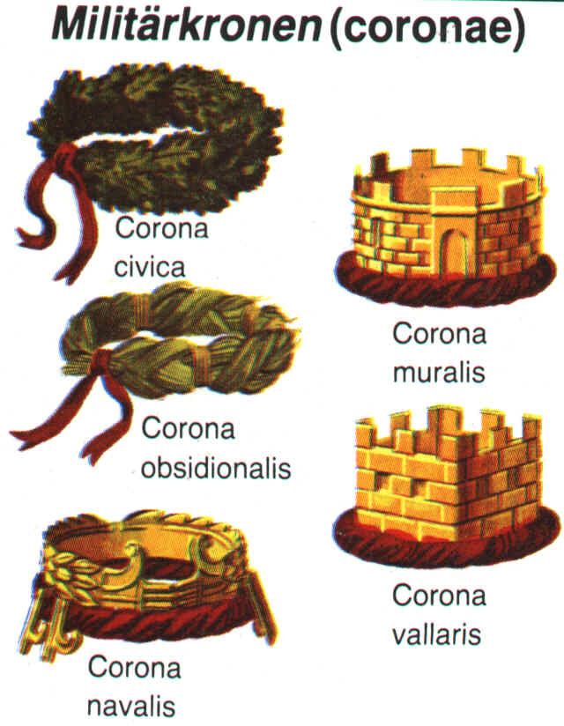
Notice that the corona or crown given is designed to celebrate the achievement of going over top to the wall

But Paul spoofs it. He says, “I declare with a solemn oath that went over a wall. It was that time I was running away from persecutors in Damascus. Yeah, I was lowered down in a basket by some of the stronger grandmas of the church.” As Tom Wright points out, “Paul is claiming an upside down corona muralis…he’s like someone applying for a job by listing all things that would normally disqualify him straight away (page 128).”

A Culture of Achievement

But what does any of this have to do with missions or the Christian life. Like the Romans, we also live in an achievement worshipping culture. Paul is not against achievement. He achieved quite a lot! We look back now and see that he was not only successful in planting churches throughout the Roman world but that he laid out a structure for church life that is remarkably transferrable to different cultures, demonstrating an effectiveness that is amazing. Like any of us, Paul wants to achieve. But that’s not what he wants most. What he wants most is to be found a faithful servant of his master. Achievements for Jesus—and even church planting can be viewed as a worldly achievement---does not necessarily demonstrate faithfulness to Jesus. But staying true to Jesus under the sort of trials Paul describes (v23-28) that does show loyalty to Jesus. It also demonstrates the preciousness of Jesus; he is a master who is worthy of such suffering love.

One of the great mysteries of the Christian life is why things don’t go as planned. A related agony is when God seems careless about fulfilling his plans or even seems willing for his plans to derail. Some Christians protest this. They like the stories where missionaries move from strength to strength, where ever new year has more conversions than the year before. Thankfully, there are such stories. But it’s not the only story God writes.

Consider the story of William Borden
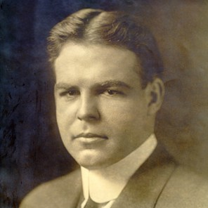
William Borden
1887-1913
(check it out on Wikipedia). God calls him to go to
The Muslim Kansu people in China.
Borden leaves behind a family business in which
he could have easily been a millionaire.
Instead, he sacrifices these excellent prospects
to share the good news to a people group far away.
Before he could settle in China though, Borden needed
Further study of Arabic in Egypt. While in Egypt
He contracted spinal meningitis. Within a month
Borden died. He was only 25 years old. He never
Even reached the mission field.

What is up with that? Why didn’t God heal him?
After all Bordens’ sacrifice, why didn’t God ensure
the very mission plan He himself inspired?
From our perspective, death isn’t even plan B. It’s like plan Z. How could God let William Borden die?

The Epitaph on Borden’s Gravestone:
Apart from Faith in Christ, there is no explanation for such a life.

Kingdom achievements are usually part of God’s plan for us but if they are the only plan, or even Plan A, then it seems to me Borden died a failure. Maybe achievement is not God’s Plan A for us. What if something else is Plan A? Come explore these missions mysteries with us this Sunday.

