Sermon Preview: Mission Mysteries: (1) Why So Small Lord?
Sunday: October 13, 2013

Text: Matthew 13:31-33

The kingdom of heaven is like…a mustard seed.

The kingdom of heaven is like…yeast mixed into flour.
Mustard seed and yeast show the truth that sometimes big power can be packed into small containers.
Jesus kingdom is like that too! The Christian movement started out so small and yet now there are Christians everywhere. Jesus predicted that people from all nations would find a home in Christianity, and like birds perch in its branches. The prophecy seemed outlandish then. Now it is reality!

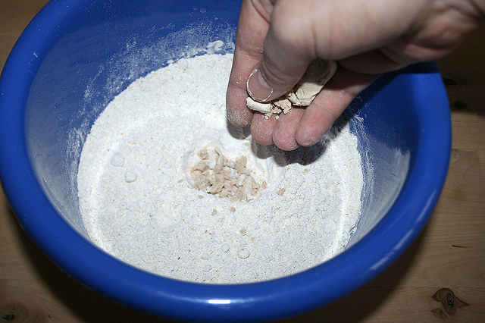
Even in our day Christianity often looks like it is weak and small. But we should not be ashamed of the gospel because it is the power of God unto salvation.
In The Lord of the Rings, the wise and powerful leaders of Middlearth give the hobbit Frodo the task to destroy the ring of power at Mount Doom. The “Council of Elrond” reason that the dark lord Sauron would never imagine that anyone would resist the power of the ring and seek to destroy. They were right. Sauron never suspected such lowly creatures could overthrow his power.
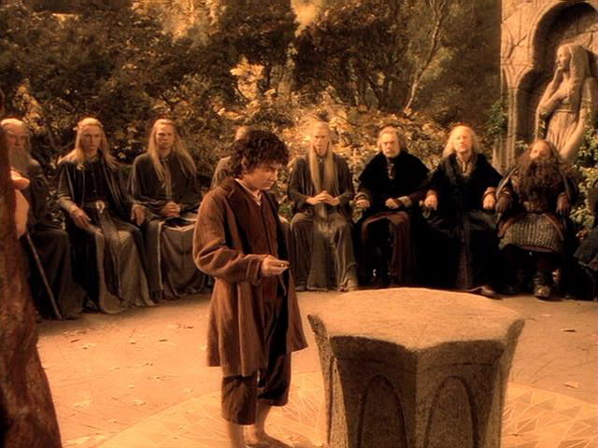

In a similar way, a lowly look is part of Christianity’s effectiveness. We read today of foreign nations like Saudi Arabia barring missionaries and preachers from America but allowing maids and service workers from Africa or the Philippines. The service workers went in “under the radar” and have effectively “spread” the gospel.
This Sunday we will see how the smallness of Christianity is actually part of its genius. Whatever kingdom service Christ calls us to do we should do it confident that God is able to make it fruitful beyond our expectations.
As the poet George Herbert says in his poem: Praise (3)
When thou dost favor any action,
It runs, it flies:
All things concur to give it a perfection.
That which had but two legs before,
When thou dost bless, hath twelve: one wheel doth rise
To twenty then, or more.

It’s old language but this poem conveys a truth that is ever fresh. God’s favor takes small services and makes them powerfully effective: two legs become twelve, one wheel becomes twenty. As the old saying goes, “Little is big when God is in it.”

